W4240 Data Mining Section 2

Rui Fan

############ 2.8 #############

##(a)

college<-read.csv("http://www-bcf.usc.edu/~gareth/ISL/College.csv", header=TRUE)

##(b)

rownames(college)=college[,1]

fix(college)

college=college[,-1]

fix(college)

##(c)

#i.

summary(college)

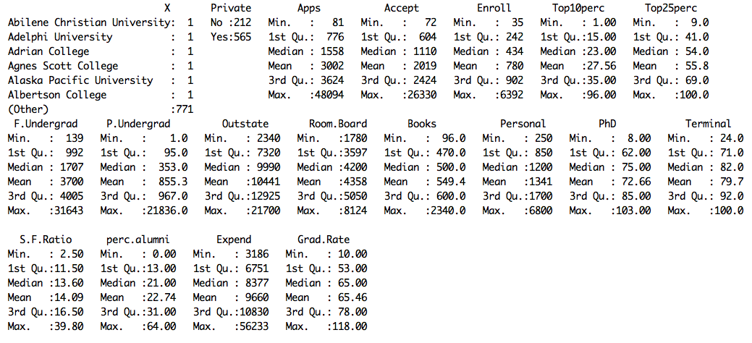

#ii.

pairs(college[,1:10])

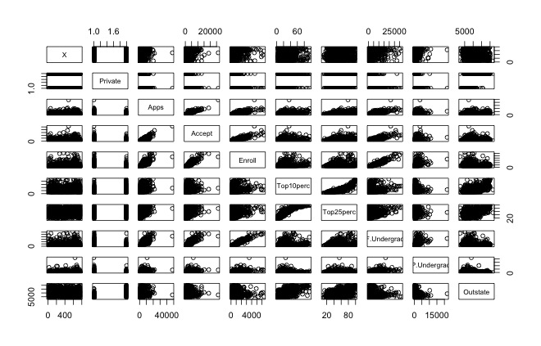

#iii.

attach(college)

plot(Outstate~Private)

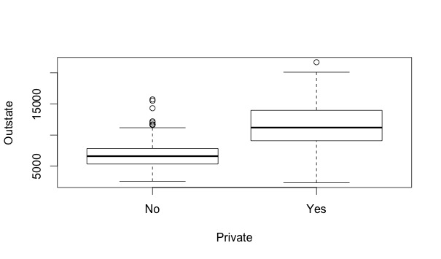

#iv.

Elite=rep("No",nrow(college))

Elite[college$Top10perc >50]="Yes"

Elite=as.factor(Elite)

college=data.frame(college ,Elite)

summary(Elite)

No Yes

699 78

plot(college$Outstate~college$Elite)

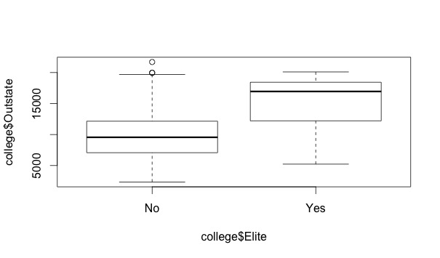

# v.

names(college)

par(mfrow=c(2,2))

hist(Personal, main="histogram on personal, bin=10",breaks=10)

hist(Personal, main="histogram on personal, bin=15",breaks=25)

hist(Grad.Rate, main="histogram on Grad.Rate, bin=10",breaks=10)

hist(Grad.Rate, main="histogram on Grad.Rate, bin=20",breaks=20)

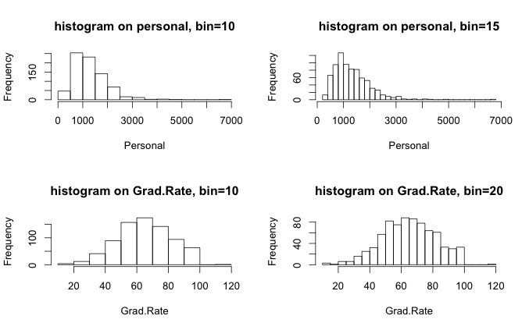

#vi.

dim(college)

[1] 777 19

class(college$)

# There are 777 subjects and 19 variables, of which 2(x and private) are categorical variable and the rest are numerical.

Also from the scatterplot we can see that some of the variables are highly positively related.

########### 2.9 ############

## a.

Auto<-read.table(file.choose(), header=T, na.strings="?")

Auto=na.omit(Auto)

names(Auto)

summary(Auto)

attach(Auto)

class(mpg)

[1] "numeric"

class(cylinders)

[1] "integer"

class(displacement)

[1] "numeric"

class(horsepower)

[1] "numeric"

class(weight)

[1] "numeric"

> class(acceleration)

[1] "numeric"

class(year)

[1] "integer"

class(origin)

[1] "integer"

class(name)

[1] "factor"

#### So except for variable “name”, the rest of these eight variable are all numeric variable and “name” is a categorical variable.

## b.

allrange<-matrix(NA,8,2)

for(i in 1:8) {

allrange[i,1]<-range(Auto[,i])[1]

allrange[i,2]<-range(Auto[,i])[2]

# Set the lower bound and the upper bound for range of each variable. And the first column of following matrix is the lower bound of each variable, the second column of following matrix is upper bound of each variable.

}

allrange

[,1] [,2]

[1,] 9 46.6

[2,] 3 8.0

[3,] 68 455.0

[4,] 46 230.0

[5,] 1613 5140.0

[6,] 8 24.8

[7,] 70 82.0

[8,] 1 3.0

## c.

meanandsd<-matrix(NA,8,2)

for(i in 1:8) {

meanandsd[i,1]<-mean(Auto[,i])

meanandsd[i,2]<-sd(Auto[,i])

Set the mean and standard deviation for range of each variable. And the first of the column of following matrix is the mean of each variable; the second column of the following matrix is standard deviation of each variable.

}

meanandsd

[,1] [,2]

[1,] 23.445918 7.8050075

[2,] 5.471939 1.7057832

[3,] 194.411990 104.6440039

[4,] 104.469388 38.4911599

[5,] 2977.584184 849.4025600

[6,] 15.541327 2.7588641

[7,] 75.979592 3.6837365

[8,] 1.576531 0.8055182

## d.

Autoremoved<-Auto[-(10:85),]

Autoremoved

summarywork<-matrix(NA,8,4)

for(i in 1:8) {

summarywork[i,1]<-mean(Autoremoved[,i])

summarywork[i,2]<-sd(Autoremoved[,i])

summarywork[i,3]<-range(Autoremoved[,i])[1]

summarywork[i,4]<-range(Autoremoved[,i])[2]

Set the mean, SD, lower bound and the upper bound for range of each variable. And the first column of following matrix is the mean of each variable, the second column is standard deviation, third column is the lower bound and the forth column is upper bound of each variable.

}

summarywork

[,1] [,2] [,3] [,4]

[1,] 24.404430 7.867283 11.0 46.6

[2,] 5.373418 1.654179 3.0 8.0

[3,] 187.240506 99.678367 68.0 455.0

[4,] 100.721519 35.708853 46.0 230.0

[5,] 2935.971519 811.300208 1649.0 4997.0

[6,] 15.726899 2.693721 8.5 24.8

[7,] 77.145570 3.106217 70.0 82.0

[8,] 1.601266 0.819910 1.0 3.0

## e.

pairs(Auto)

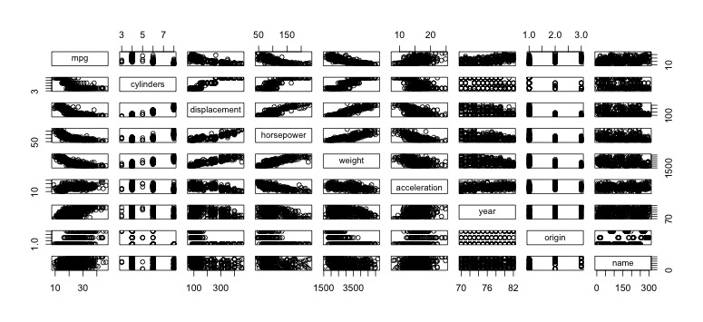

#From the scatterplot above, we can see that there are negative relationships between the mpg and displacement, weight, year as well as origin.

## f.

fit<-lm(mpg~cylinders+displacement+horsepower+weight+acceleration+year+origin)

summary(fit)

Call:

lm(formula = mpg ~ cylinders + displacement + horsepower + weight +

acceleration + year + origin)

Residuals:

Min 1Q Median 3Q Max

-9.6524 -2.0723 -0.0504 1.8022 13.0248

Coefficients:

Estimate Std.Error t value Pr(>|t|)

(Intercept) -2.182e+01 4.266e+00 -5.115 4.94e-07 \*\*\*

cylinders -2.413e-01 3.382e-01 -0.714 0.4760

displacement 1.558e-02 7.265e-03 2.144 0.0326 \*

horsepower 1.129e-02 6.991e-03 1.615 0.1071

weight -6.837e-03 5.797e-04 -11.795 < 2e-16 \*\*\*

acceleration 1.520e-01 7.738e-02 1.964 0.0503 .

year 7.745e-01 4.930e-02 15.709 < 2e-16 \*\*\*

origin 1.359e+00 2.685e-01 5.062 6.41e-07 \*\*\*

---

Signif. codes: 0 '\*\*\*' 0.001 '\*\*' 0.01 '\*' 0.05 '.' 0.1 ' ' 1

Residual standard error: 3.326 on 389 degrees of freedom

Multiple R-squared: 0.8226, Adjusted R-squared: 0.8194

F-statistic: 257.7 on 7 and 389 DF, p-value: < 2.2e-16

## The result confirms what I expected.

########## 3. #############

a.

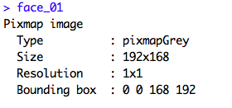

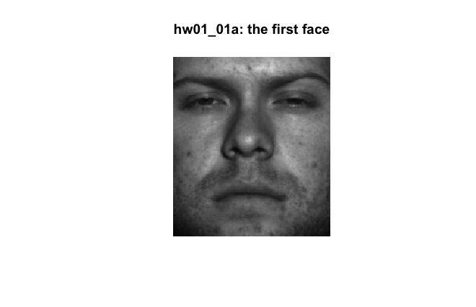

> class(x)

[1] "numeric"

## So x is numerical and the size of the original image in pixels is 192\*168.

## b.

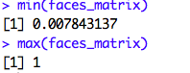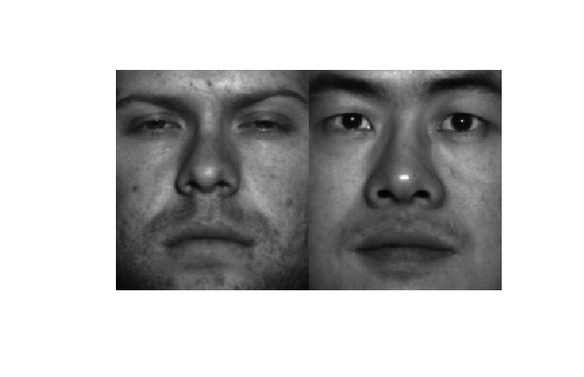

##0.007843137 corresponds to almost transparent, and 1 corresponds to black.

## c.

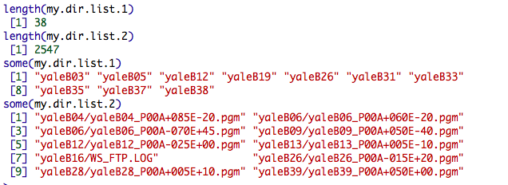

## d.

Macintosh HD:Users:fanrui:Desktop:data mining:HW1:hw01_01d/3*3 grid of faces.pdf